What is a Number Sequence
Number sequences in Dynamics 365 F&O are essentially a series of unique identifiers assigned to records within the system. They distinguish and categorize various transactions, such as sales orders, purchase orders, invoices, and financial journals. Organizations can maintain accurate records and facilitate smooth data retrieval by assigning a unique sequence to each transaction.
Number Sequences can be created in two different ways:
- Using a Wizard
- Manually
Using a Wizard
You would generally use this Wizard for a new legal entity or bulk creation of default number sequences.
- Go to Module > Organization administration > Number sequences > Number sequences.

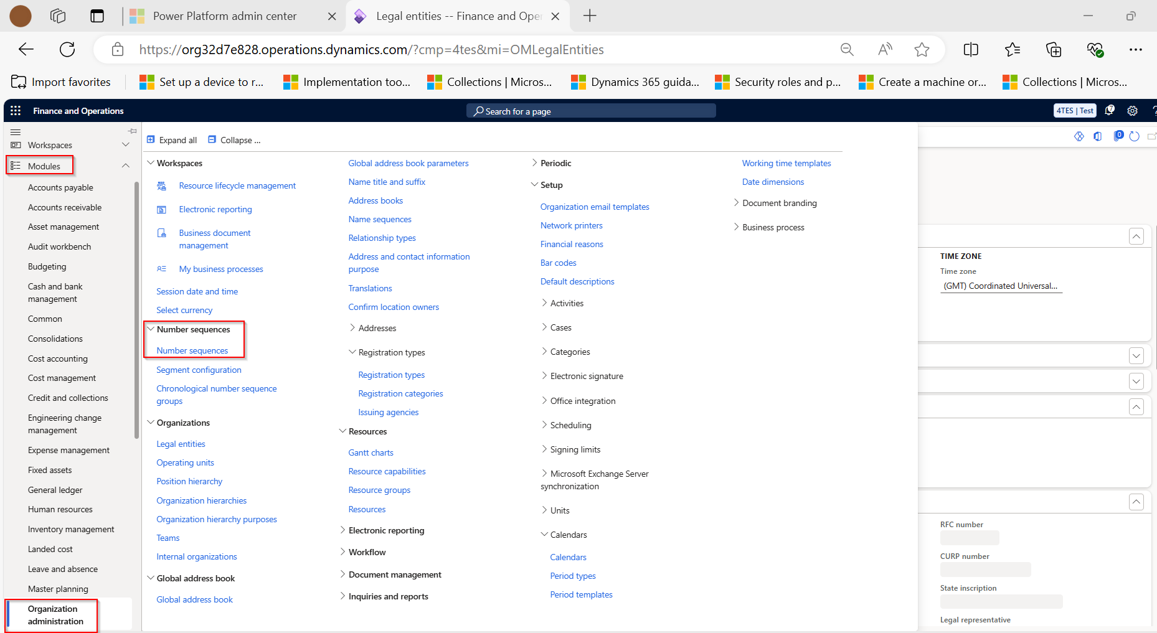
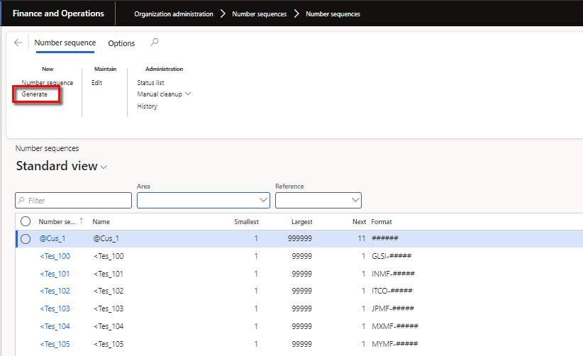

This is a global setup (Shared Form), so the NS of every LE will be visible on the screen.

- Select Generate to initiate the Wizard.
- The Wizard is divided into 3 steps, and all you need to do is review the process and click Next.
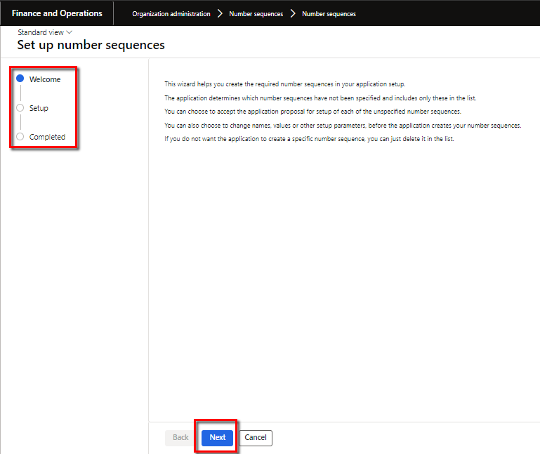

- On this page, you can modify the identification code, the lowest value, and the highest value. In addition, you can indicate whether the number sequence must be continuous.
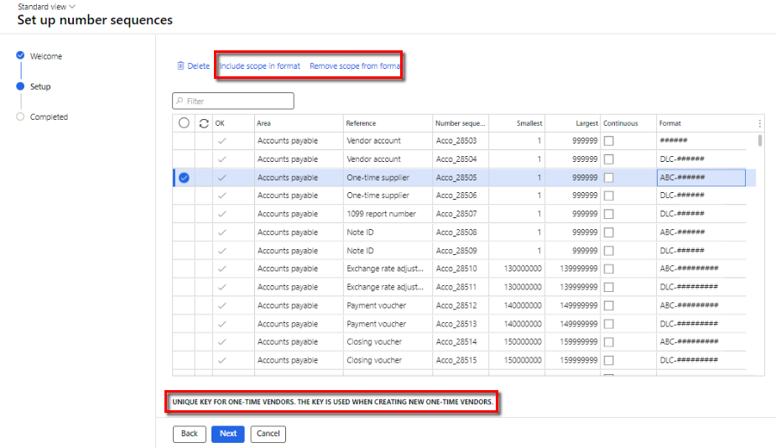

- You can make a number sequence Continuous by selecting the option. To add a scope segment to the format of a number sequence, choose the format from the list and then select Include Scope in format, or to remove it, select Remove Scope in the format.
- To exclude a number sequence from automatic generation, select the number sequence in the list and then select Delete.
- At the bottom of the table, you will find short descriptions of each and every number sequence.

- Once you click Next, you will be taken to the page where you can see the summary of all the new number sequences created. Click Finish to complete the process.
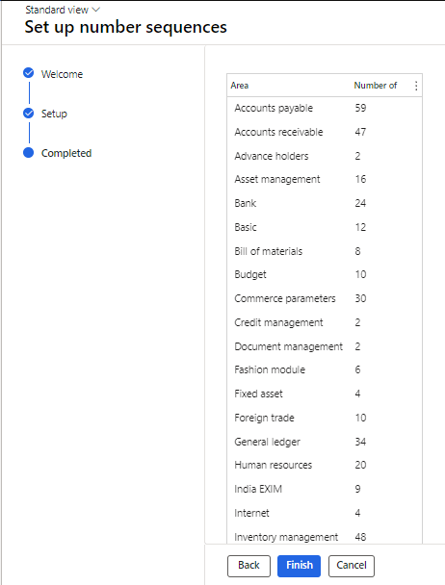

Note: This process can be used only once, i.e., when creating the Number. If you try to Generate number sequences using this option for the second time, the system will throw the error messages below.

Manual Process
If you need to create a new number sequence manually, you can do it from two different places:
Option-1
- Go to Module > Organization administration > Number sequences > Number sequences.



Click on Number Sequence under the New option.
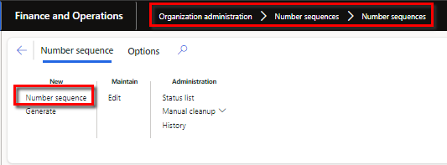

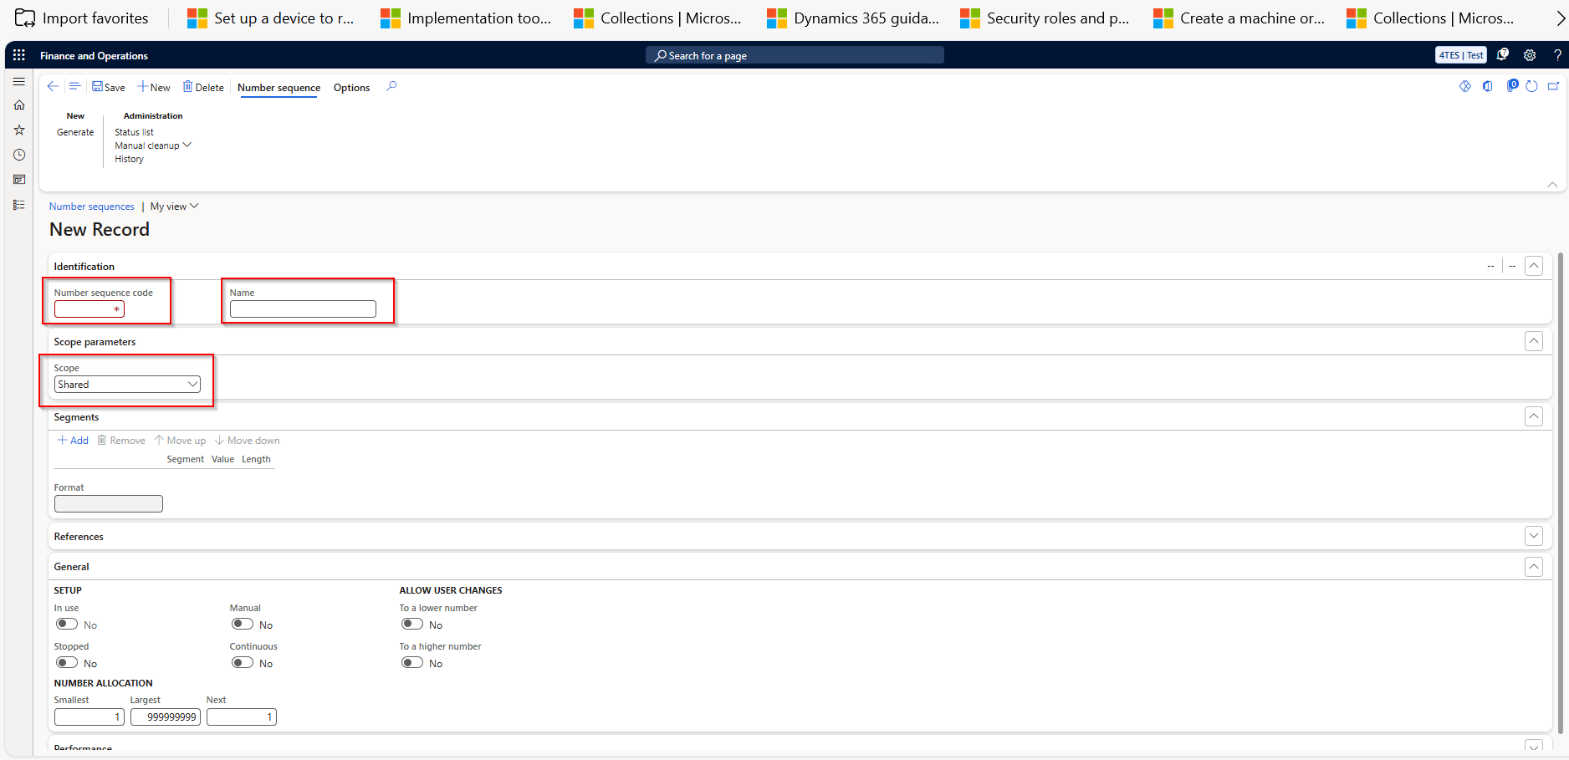

- Fill in the Number Sequence Code and the Name under Identification FastTab. (Mandatory)
- Under the Scope Parameters FastTab, you will see multiple options to select from to decide the Scope of the number sequence. Following are the details of each option:
- Shared—This option is used when a single number sequence is used for all organizations. The shared Scope is available only for some reference/functions.
- Company—This option is used when a separate number sequence is used for each company. Use the Company scope when the underlying table includes the "DataAreaId" field, E.g., for the Customer Table. (Select This option and select your company name)
- Legal entity—This option is used when a separate number sequence is to be used for each legal entity. Use the Legal entity scope when the underlying table does not include the DataAreaId field, e.g., for the Expense Report.
- Operating unit - This option is used when a separate number sequence is used for each operating unit. Select the Operating unit after selecting this option. For example, select one of the departments or the cost centre.
- Company and fiscal calendar period—This option is used when a separate number sequence is used for each company and fiscal calendar period combination. A combination of the Company and Fiscal calendars needs to be selected here to proceed.
- Legal entity and fiscal calendar period - This option is used when a separate number sequence is used for each legal entity and fiscal calendar period combination.
- Operating unit type - A separate number sequence is used for each type of operating unit. This is a high-level number sequence for the Operating Unit option above. For example, select the whole department or the cost centre.
- Once you have selected the Scope, the next line will set the format of the number sequence under the Segments Fast Tab. So here, the fields will differ depending on the option selected in the Scope.
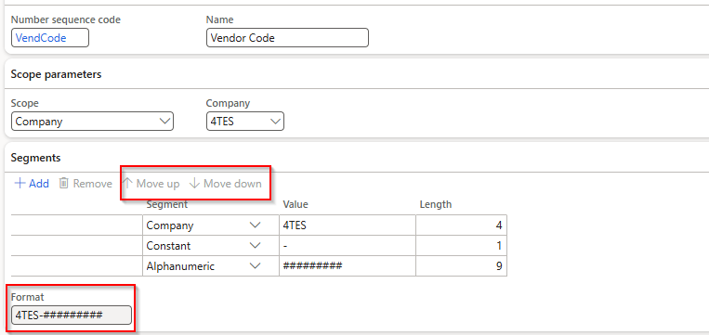
- In this section, we will set the format to add or remove the different segments, such as Company, Constant, or Alphanumeric. These options can be deferred according to the Scope selected.
- The following section is Reference, where we can either manually link the same or the system will populate this FastTab once we map the number sequence on the parameter form.
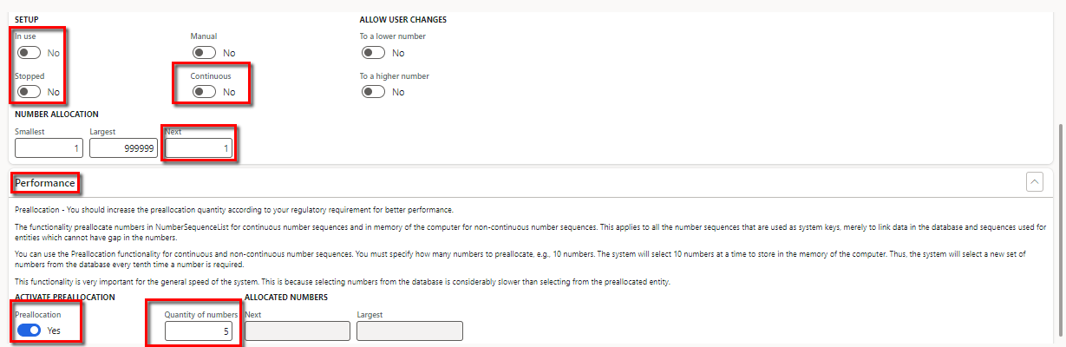
- The next FastTab General, also called Setup, is the most essential part that determines the system's performance in high-volume transactions.
- There are multiple options/bullion to opt for; the In Use Toggle will be automatically set to Yes when it is mapped to a particular reference and generates one of the sequences.
- Use the Stopped Toggle if we do not want to use the number sequence anymore, and the system will not be able to generate numbers based on this number sequence.
- Use the Manual Toggle when you want the user to fill in the Number manually. If no format is set, it can be a defined number sequence. If the format is set, the user can still manually fill in the Number, but it has to follow the format.
- Under the Allow User Changes section, use the To a lower number Toggle when you want to allow users to edit the number sequence to a lower value than the already generated Number. Select the To a higher number Toggle to enable users to edit the number sequence to a higher value than the already generated Number.
- The Number Allocation option shows the Smallest, Largest, and Next numbers in the sequences. You can manually change the data in the Next field if you get an error about the already used voucher.
- Now, talking about the most critical Setup, Continuous Toggle, specify whether the number sequence is continuous or non-continuous.
A continuous (CNS) number sequence doesn't skip any numbers, but numbers may not be used sequentially. Numbers from a noncontinuous (NonCNS) number sequence are used sequentially, but the number sequence may skip numbers.
Deciding whether the number sequence should be a CNS or NonCNS is very important. This decision can, post-go-live, determine the performance of the system and the process.
You should select Continuous number sequence in case where there is legal compliance point or if it is a document to be used/shared out with stakeholders outside the organisation. For others it's advisable to use Non continuous, specially for internal documents/process where the data/process volume is high.

Note: From Version 10.0.36 Microsoft has brought a new feature which has resolved a long due issue of performance when the number sequence is in continuous. Feature is called 'Enable continuous number sequence performance improvements', it is not auto active.
If you will see the Performance fasttab was earlier only enabled for NonCNS number sequnce only but now it is available also for CNS sequences just to ensure the performance matches that of a NonCNS.
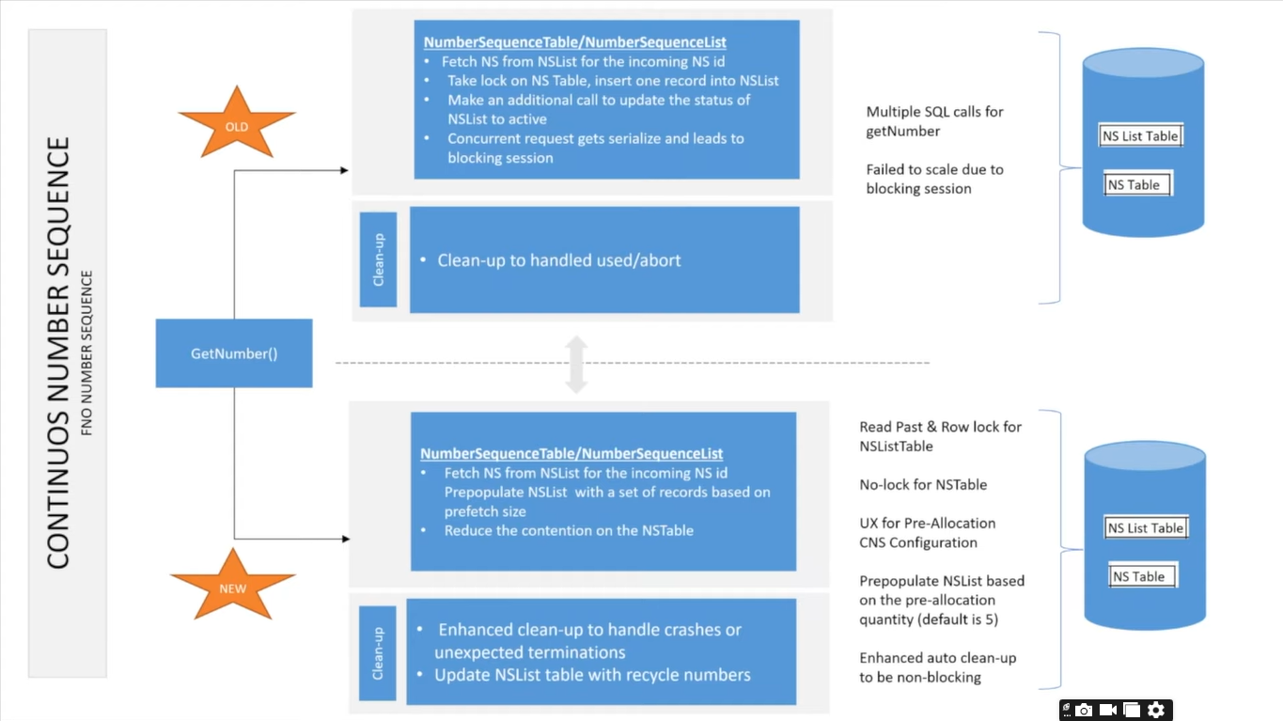
- Automatic Clean-up FastTab appears only when you enable the Continuous option. This option, when enabled, cleans up the unused numbers at the interval defined in the Setup. By default, this is set at 24 hours, but we can move it to even so that the clean-up happens only on weekends. This way, the clean-up batch does not run during peak hours and does not happen in day-to-day operations.
- You can run the clean-up process manually or automatically to recover the lost numbers.
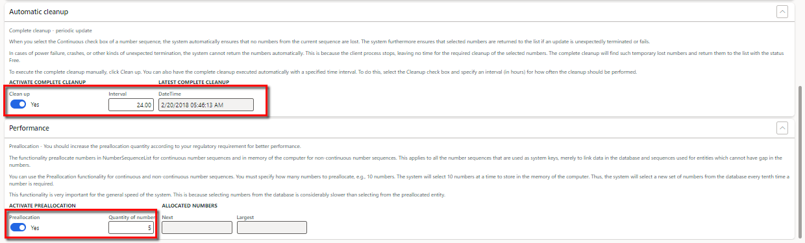
- Performance FastTab and Preallocation were earlier available only as a non-continuous option, but after the new update in version 10.0.36, this option is now available for continuous Sequence. This helps to block a set of numbers when a user uses the Sequence. For CNS cases, the blocked numbers are saved on the database, which was earlier not the case, leading to delays in processing and missing the numbers in between.
- Preallocation helps in case of a network issue where the AOS server connection is broken or in cases where multiple people are working on the same process. When you specify a quantity of numbers to preallocate, the system selects those numbers and stores them in memory.
- The Quantity in Number field can have a value based on the volume of data processed on a day-to-day basis; you need to analyse this well before configuring it on production. All the load testing can be done on the sandbox environment or other equivalent environment.

ADDITIONAL RESOURCES
https://learn.microsoft.com/en-us/dynamics365/fin-ops-core/fin-ops/organization-administration/number-sequence-overview

https://learn.microsoft.com/en-us/shows/dynamics-365-fasttrack-architecture-insights/finance-and-operations-number-sequence

